Extra Practice Problems

Please show all of your work for maximum credit. Good Luck!!!

1. On the unit circle to the right, label the indicated “common” angles with their degrees and radian measures. Also, label the cosine and sine of each angle.

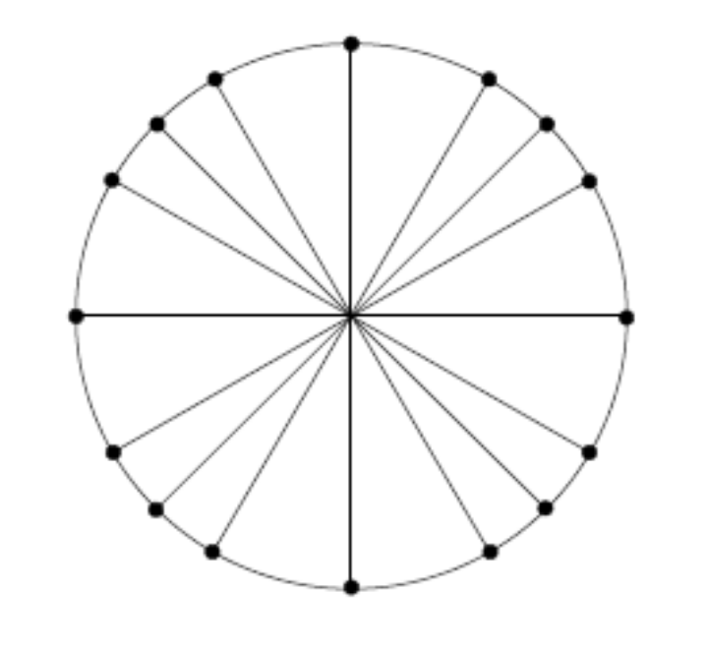

2. Also, graph the function over two full periods.

3.
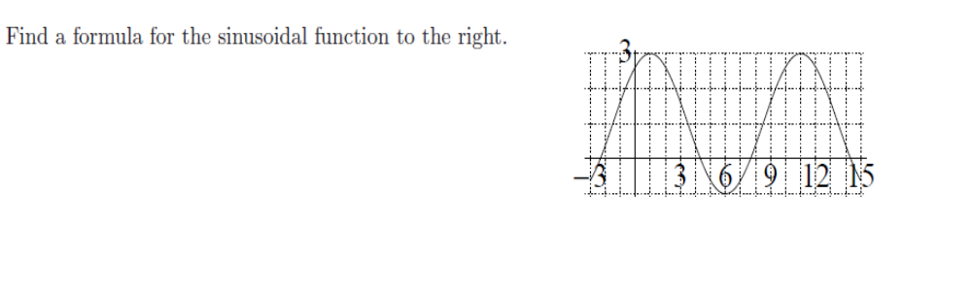

4. A population of animals oscillates annually from a low of 1300 on January 1st to a high of 2200 on July 1st, and back to a low of 1300 on the following January. Assume that the population is well-approximated by a sine or a cosine function.
(a) Find a formula for the population, P, as a function of time, t. Let t represent the number of months after January 1st. (Hint. First, make a rough sketch of the population, and use the sketch to find (the amplitude, period, and midline.)

5.
6.
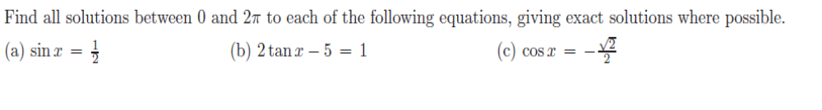

7.
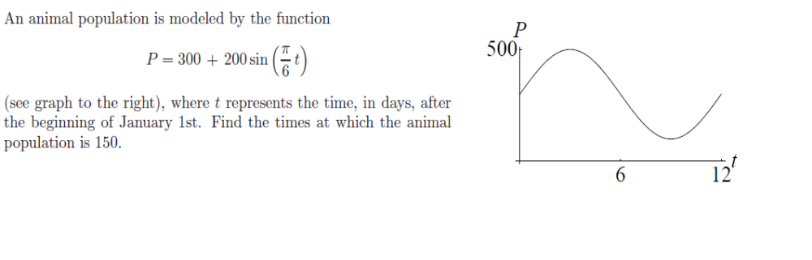

8. Solve each equation for , an angle in a right triangle

( a )

( b )

9.
